How to set up new ledger code on FMS

Tools/General Ledger Setup
Select Tab 5 - Ledger Codes
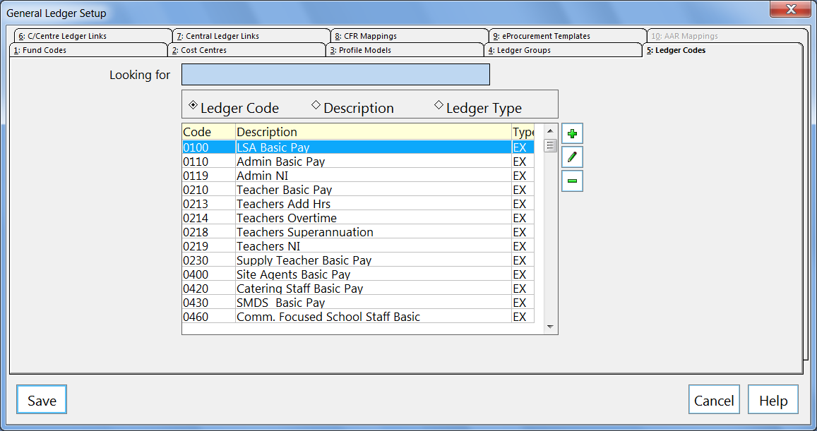
Click on +
Select type of ledger code to create - Salary Expenditure
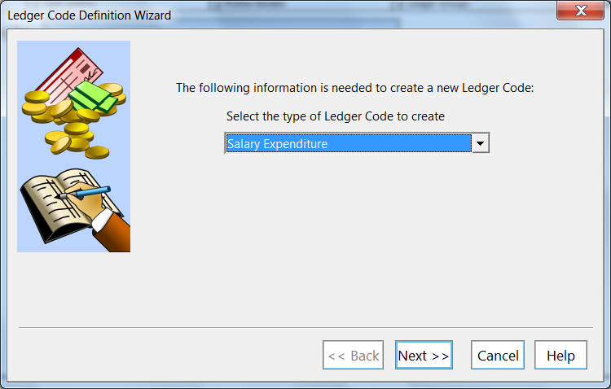

Click on next
Select the group to which new ledger code belongs
Click on spy glass, highlight E01 Teaching Staff - Select
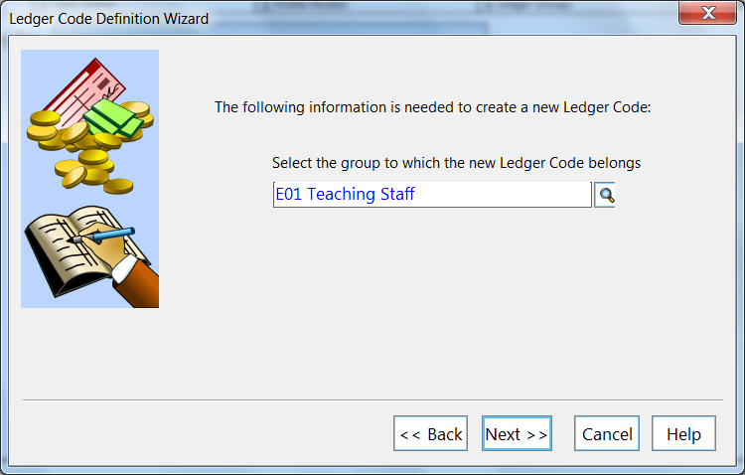
Click on next
Default fund for this ledger code
Click on spy glass - School Fund - Select
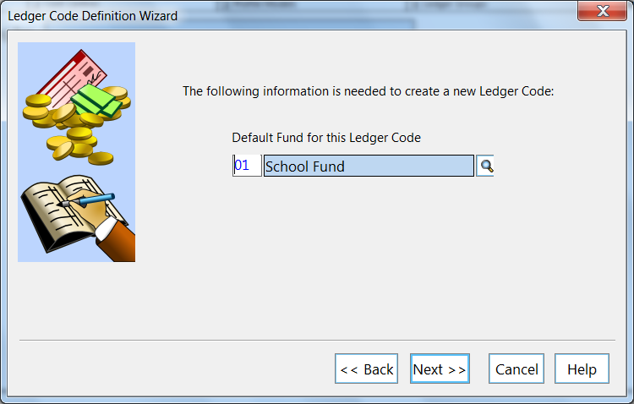
Click on next

Enter new code - 0200
Enter new description for ledger code - Teachers Leadership
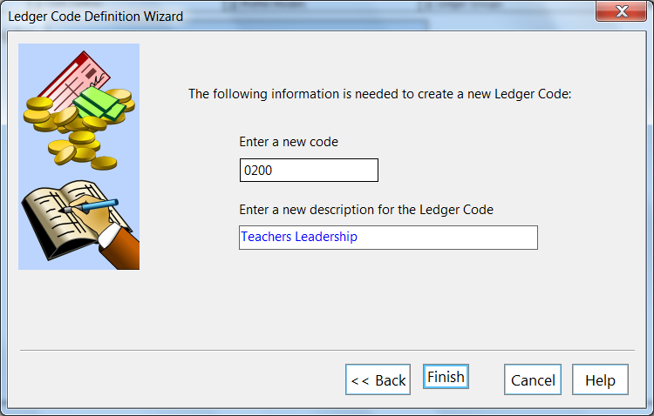
Click on finish
Ledger Code Definition box appears
Check details for accuracy
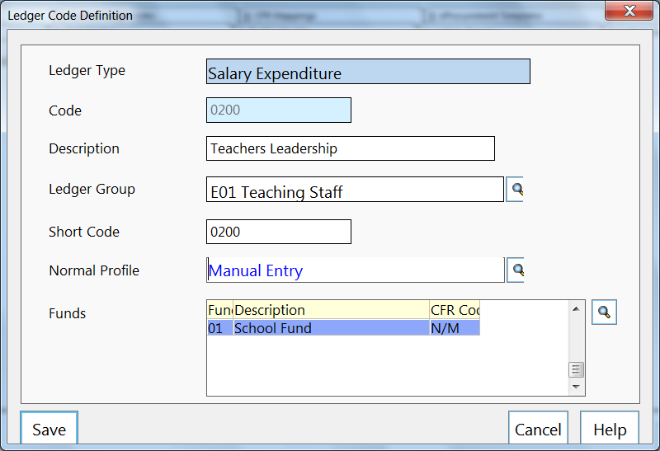
Click on save
Select Tab 6 - Cost Centre Ledger Links
Prompt - Do you wish to save your changes - Yes
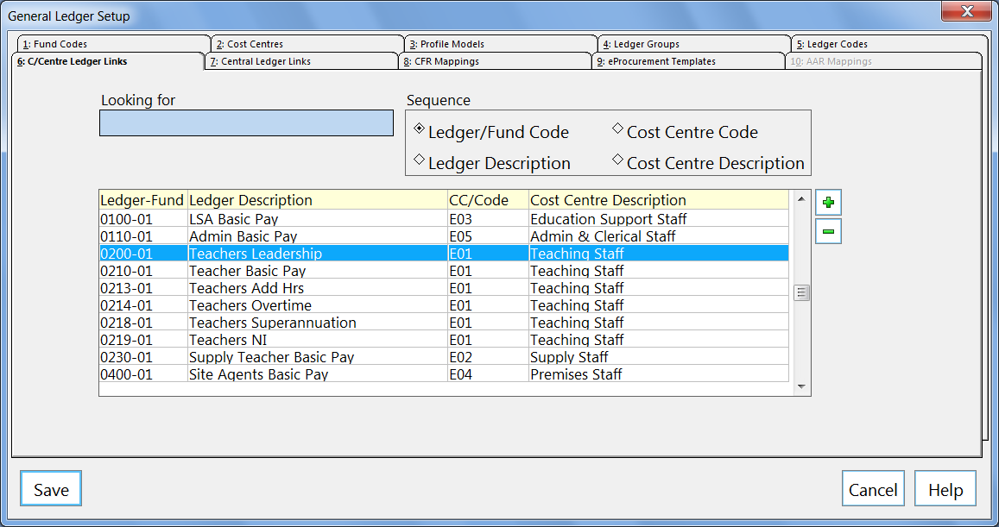
Click on +
Available Cost Centres, Select E01, Small arrow to take across into chosen cost centre box
Available Ledger Codes, Select 0200, Small arrow to take across to chosen ledger codes
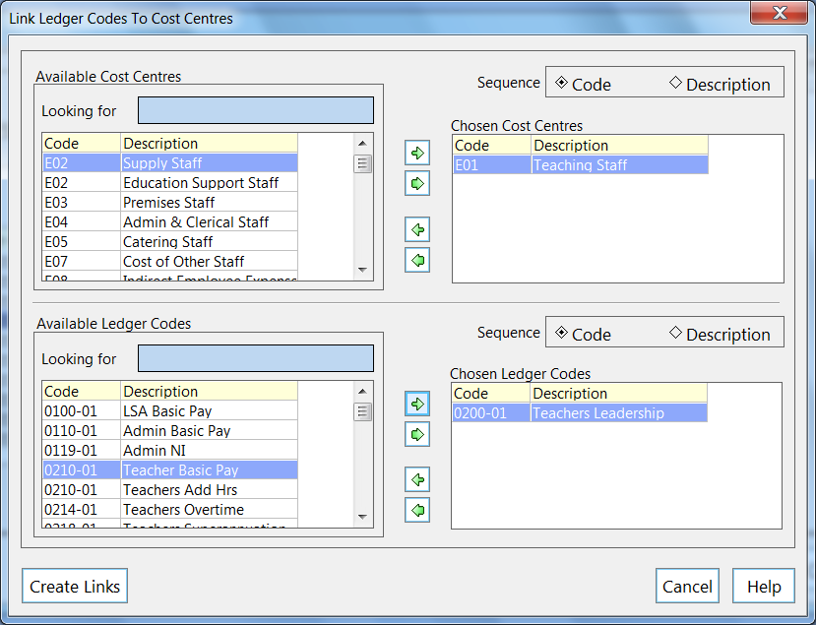
Click on create links
Click on OK
Select Tab 8 - CFR Mapping
Prompt - Do you wish to save your changes - Yes
Code heading, Select CFR code - E01
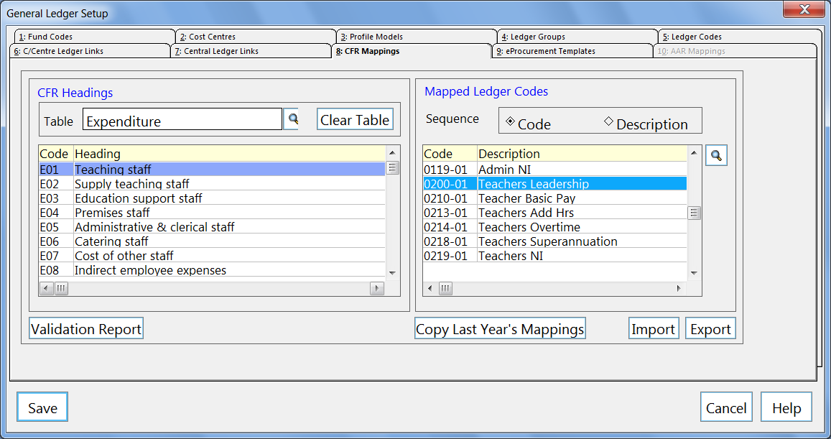
Click on spy glass
Select code 0200, Small arrow to take to chosen codes
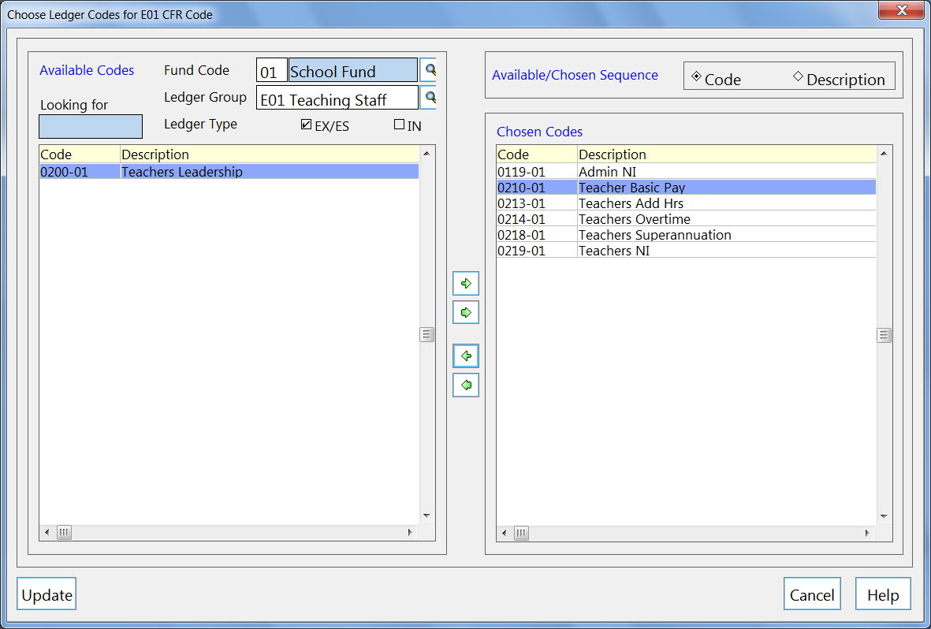
Click on update
Click on save

